**AN ANDROID APPLICATION FOR KEEPING UP WITH THE LATEST HEADLINES**

|  |  |
| --- | --- |
|  |  |
|  |  |
|  |  |
|  |  |

**REQUIRED INITIAL STEPS:**

**Step 1:** Visit the official Android Studio Website.

go to the [**https://developer.android.com/studio**](https://developer.android.com/studio)

**Step 2:** Select the version of your operating system.

* On the website,you will see download options for windows,macOS,and Linux.
* Click on the approximate version for your computer.

**Step 3:** Read and accept all the terms and conditions.

* Read through the terms and conditions,and then click on **“I have read and agree with the terms and conditions”** checkbox before proceeding.

**Step 4:** Click download button and start downloading.

* Click on the **“Download”** button to begin downloading the installer file.

**Step 5:** Wait for download to complete and proceed installation.

* Once the download completes,you can proceed with the installation.

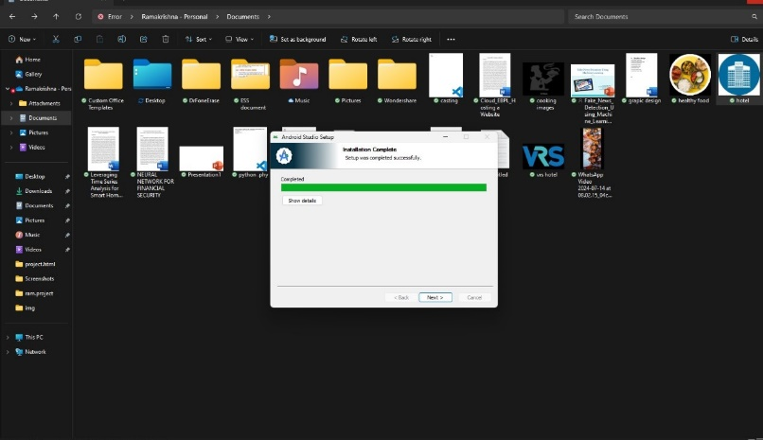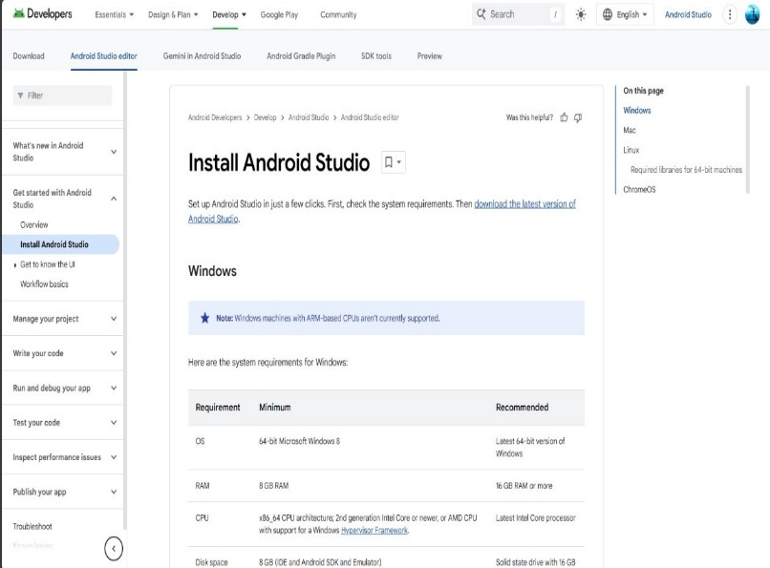

**FIG 2:** INSTALLATION

**FIG 1:** INSTALL ANDROID STUDIO

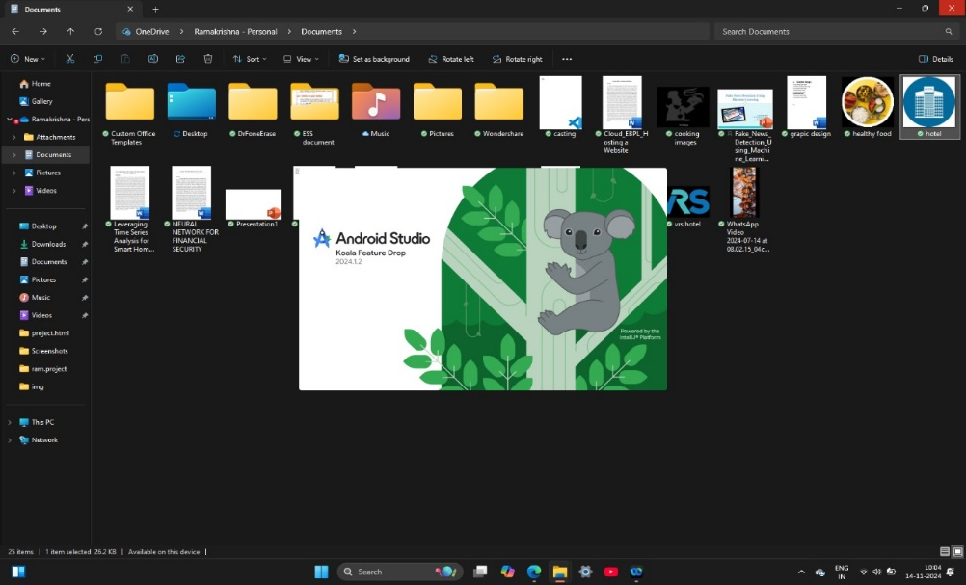

**FIG 3:** AFTER THE INSTALLATION